
XR Simulation Learning Platform
Functional Requirement Document
Consolidated Updated Draft — Version 5.0
Core Edition — Primary Stakeholder Review Document

Based on Platform FRD_v4, PM-Confirmed Clarifications and Review 006
Status | DRAFT FOR REVIEW — NOT YET APPROVED
Date | 19 August 2026

The original Platform FRD_v4 remains unchanged. This consolidated draft preserves the original requirement IDs, records approved PM clarifications and additions, and identifies pending decisions for stakeholder review.

The v5 Document Set
You are reading the Core FRD. Four documents make up the v5 requirement set. Each answers a different question, and each says so on its first page so that no one reads the wrong one.
Table 1 — The four documents and what each is for
Document | Purpose | What is in it
Core FRD  Platform_FRD_v5_  CORE_DRAFT_FOR_  REVIEW | Primary review document. Read this to understand what is being built. | 30 pages. Scope, architecture, roles, capabilities, key workflows, the stakeholder decisions, the changes from v4, high-priority open questions and the sign-off table.
Team Lead Review Summary  Platform_FRD_v5_  TEAM_LEAD_REVIEW_  SUMMARY | Quick discussion document. Read this to understand what changed and what needs decisions. | 11 pages, mostly diagrams. What the project is, what the earlier reading missed, what the stakeholder confirmed, and what needs a decision next.
Detailed Master  Platform_FRD_v5_  DRAFT_FOR_REVIEW | Complete requirement, traceability and audit reference. Use this when exact requirement provenance or detail is needed. | 147 pages — long by design. All 131 original requirements with faithful wording, the traceability matrix, every acceptance criterion, the complete open-question register, the dependency register and the full decision records. Not intended to be read front to back.
Original FRD v4  source/  Platform FRD_v4.pdf | Historical issued source. Remains unchanged. | The issued baseline. Nothing in the v5 work edits it. Where v5 departs from it, the departure is recorded as a deviation or an extension rather than applied to the original.

One rule that holds across all four
• The original Platform FRD_v4 is never edited. Every departure from it is recorded as a deviation, an extension, or a gap — with its source named — rather than absorbed into the requirement text.
• The compact editions do not narrow scope. Where they summarise, the full detail remains in the Detailed Master and is cross-referenced.

1. Document Control
Table 2 — Document control
Field | Value
Document title | XR Simulation Learning Platform
Document type | Functional Requirement Document (FRD) — Core Edition
Version | 5.0 — Consolidated Updated Draft, revision 2
Date | 19 August 2026
Status | DRAFT FOR REVIEW — NOT YET APPROVED
Purpose | The primary stakeholder review document. It is written to be read end to end and to be explainable without opening the detailed master.
Source document | source/Platform FRD_v4.pdf — 17 pages, 12 sections, 131 numbered requirements. Unchanged by this work.
Supporting sources | Stakeholder confirmations of 18 August 2026 (PM-01 – PM-12) and 19 August 2026 (PM-13 – PM-15); the full-platform requirement re-audit; earlier design material where compatible.
Prepared for | Project Manager and Team Lead, XR Simulation Learning Platform programme
Prepared by | [Prepared-by name and role to be completed before circulation]
Approval status | Not approved. Issued for stakeholder review only. The sign-off table is at chapter 22.
Companion documents | Team Lead Review Summary (for discussion) · Detailed Requirements and Traceability Reference (for provenance) · Platform FRD_v4 (the unchanged original)

Preservation notice
The original Platform FRD_v4 remains unchanged. This consolidated draft preserves the original requirement IDs, records approved PM clarifications and additions, and identifies pending decisions for stakeholder review.

1.1 Revision history
Table 3 — Revision history
Version | Date | Summary of change
v4 | As issued | Original Platform FRD — 12 sections, 131 numbered requirements, three phases. Held unchanged.
v5 Draft | 19 August 2026 | Full-platform consolidation based on stakeholder clarification and the requirement re-audit. All original requirement identifiers preserved.
v5 Draft rev 2 | 19 August 2026 | Accuracy hardening (see 3.4) and the compact review editions, of which this is one. No requirement removed and no scope changed.

1.2 Accuracy corrections in this revision
Seven claims in the first v5 draft asserted more than the sources support. They have been corrected in every edition of this document set. The corrections narrow what the document claims; none of them changes scope, and none removes a requirement.
Table 4 — Accuracy corrections applied
Topic | Corrected position | Why the original wording overclaimed
Direct course purchase | Phase-1 purchase requirements explicitly define individual module and bundle purchasing. Direct course purchase is not specified and is not included in the current design unless subsequently approved. Classified NOT-SPECIFIED / PRODUCT-PENDING (`QP-28`). | No source prohibits course purchase. Absence of a requirement is not a prohibition.
Assessment hints | Hints are classified OPTIONAL / PRODUCT-PENDING. No hint behaviour, hint scoring or hint limit is assumed in either direction (`QP-20`). | PM-08 confirms configurable assessment behaviour. It does not mention hints, and no FRD requirement defines them.
Answer-key visibility | Answer-key visibility and post-attempt feedback policy are PRODUCT-PENDING. Learner-facing applications must receive only the assessment data permitted by the configured and approved feedback policy (`QP-27`). | Neither the FRD nor any stakeholder decision states a feedback policy. The rule was a design inference.
Authentication and role routing | PM-03 confirms one central platform, role-based access and workspaces, and that institutional SSO is required. The sign-in model and the absence of a pre-login role choice are DESIGN-PENDING design positions (`QX-10`). A workspace chooser remains available only as a conditional pattern if multi-role identities are later approved (`QP-11`); none is mandated. | PM-03 does not specify a sign-in model, and no source addresses multi-role identities.
Role set | Seven formal roles are currently approved for Phase 1. Any additional Phase-1 formal role requires explicit stakeholder approval. | The original wording asserted a permanent closure that no source establishes.
Institutional SSO | Institutional SSO is required and is available according to the institution's configured authentication model. Provider, protocol, attribute mapping and fallback remain pending. | “Preferred” understated a confirmed requirement and implied a prominence decision no source makes.
Other inherited design positions | Each is relabelled DESIGN-PENDING and attributed to the reasoning behind it rather than to a requirement. | All three were legitimate design inferences from earlier work, but none is stated by a source.

The principle behind all seven
• A requirement document may record what a source says, and it may record a labelled design position. It must not present the second as the first.
• Absence of a requirement is not a prohibition. Where nothing is specified, the correct entry is NOT-SPECIFIED or PENDING — not a rule invented to fill the space.

2. Executive Summary

2.1 How to explain this platform in 60 seconds
The 60-second version
• We are building one web platform that delivers engineering simulation experiments to students — some in a browser, some on a VR headset, some on a phone.
• Content comes from outside. A vendor uploads an experiment. An academic reviewer checks it teaches the right thing. A content manager checks the files and details. Only then can a super admin publish it.
• There are two ways to get access. An institution buys a licence and its faculty assigns the content to students, or an individual buys a module for themselves. Either way the result is the same thing: an entitlement that says who is allowed to open what.
• Then the learner works through it — read the resources, run the simulation, take the assessment, module complete. The platform records what they did.
• Seven kinds of user each get their own area of the same platform: learner, faculty, institute admin, vendor, academic reviewer, content manager and super admin.

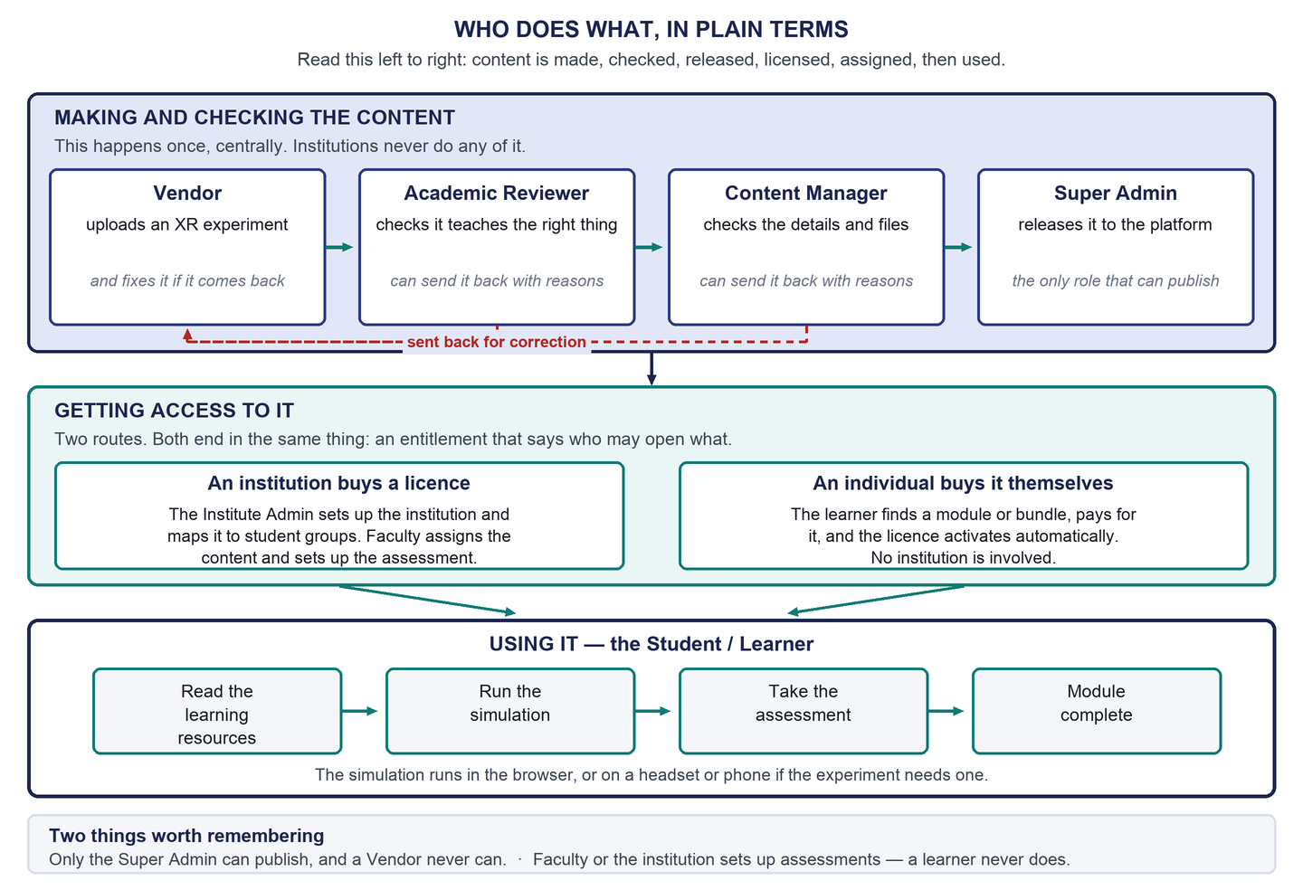
Figure 1 — How the main roles work together

2.2 What this document covers
Platform FRD_v4 defines the product and is unchanged. This edition consolidates it with fifteen stakeholder confirmations and a full-platform requirement re-audit, and presents the result as one readable requirement document. It covers scope and phasing, the platform architecture, the seven roles, the functional capabilities, the key end-to-end workflows, the XR delivery and assessment models, the integration boundaries, and what is still undecided.
It is a review draft, not an approved baseline. Where a decision has not been taken, this document says so rather than filling the gap. That is deliberate: an invented answer in a requirement document gets quoted, designed against, and eventually built.

2.3 The seven things worth knowing
Table 5 — The seven points that matter most
# | Point | Consequence
1 | Scope is the whole Phase-1 platform, not one role | Six of the seven user areas had never been designed. That is the main body of new work.
2 | Both institutional and individual models are in Phase 1 | Neither comes first. Both routes must exist, and they share one learning experience.
3 | Content passes four gates before anyone can use it | Four different people, four decisions, one publisher. Two of them can send work back.
4 | An entitled experiment must be able to reach the device that runs it | The requirement is confirmed. How it reaches the device is deliberately not decided yet.
5 | Assessments are configured, not fixed | Faculty or the authorised institution side sets the rules. No number is a platform constant.
6 | Institutional single sign-on is required | It resolves a contradiction inside the original FRD. The provider and protocol are still open.
7 | Certification moves to Phase 2 | This is a stakeholder decision that departs from the original FRD, and it is recorded as such.

2.4 What is still open
There are 59 open questions, of which 12 are high-priority. None of them blocks the architecture or the role model. Several block development of a specific capability. Chapter 20 lists all twelve high-priority items; the complete register is in the Detailed Requirements and Traceability Reference.
Four of the open items are pending because a stakeholder deliberately left them open, not because this document failed to answer them: the XR delivery mechanism, the single-sign-on provider and protocol, which institution supplies an assessment for a purely individual learner, and the detailed reporting metrics.

3. Why Version 5 Exists

3.1 The original FRD is unchanged
Platform FRD_v4 is the issued source. Nothing in this work edits it. Where this document departs from it — and there are two such places — the departure is recorded as a deviation with its cause named, rather than applied to the original text.

3.2 The earlier reading was too narrow
The design work that followed the original FRD was carried out on the understanding that the detailed Phase-1 scope was the student's desktop experience. On 18 August 2026 the Project Manager confirmed that this was too narrow: all Phase-1 requirements and all Phase-1 roles are in scope.
Table 6 — What changed and what did not
 | Earlier reading | Confirmed position
Requirement breadth | 78 Phase-1 requirements | Unchanged — still 78
Roles in design scope | 1 (Student / Learner) | 7
Areas of the platform designed | 1 | 1 designed, 6 never looked at
Earlier learner work | The product | Reusable — reclassified as one area within the platform
Cost of the correction | — | Low. No detailed visual design had been produced, so nothing had to be discarded

A further session on 19 August 2026 settled the three most structural open points: where the content-side roles sit relative to institutional data, whether submitted content can be sent back for correction, and who owns assessment setup.

3.3 The full-platform perspective
Looking at the platform whole rather than through one role changed three things. First, every Phase-1 requirement now has a named owning role, which exposed eighteen requirements with no designed surface anywhere. Second, the content governance chain — the most precisely specified sequence in the original FRD — turned out to be entirely undesigned, because three of its four actors were outside the earlier scope. Third, several requirements that looked like system behaviour turned out to need an administrator-facing surface: an institution cannot configure single sign-on or an ERP connection without somewhere to do it.

3.4 Where the accuracy record is
Seven claims in the first v5 draft asserted more than the sources support and have been corrected in every edition. The record is in section 1.2 above, and the reasoning behind each correction is in the Detailed Requirements and Traceability Reference.

4. Scope and Phasing

4.1 How the numbers work
The original FRD contains 131 numbered requirements: 78 in Phase 1, 33 in Phase 2 and 20 in Phase 3. Those counts are facts about the document and this work does not change them. Two adjustments produce the set we are working to, and both are stated openly.
Table 7 — How the Phase-1 working set is derived
Step | Count | Basis
Original Phase-1 requirement count | 78 | Platform FRD_v4 — unchanged fact
Less the two certification requirements moved to Phase 2 | −2 | PM-12 — a recorded deviation
Phase-1 set from the FRD | 76 | Derived
Plus one Phase-3 requirement given a Phase-1 working position | +1 | PM-10 — resolves a contradiction inside the FRD
Phase-1 working set | 77 | Derived

Two things this document is careful about
• Certification. The original FRD puts certification program structure and completion criteria in Phase 1. PM-12 moves both to Phase 2. That is a deviation from the FRD as written, not a correction of it, and the original phase is preserved everywhere it appears.
• Single sign-on. The original FRD puts SSO configuration in Phase 1 and SSO authentication support in Phase 3 — it contradicts itself. PM-10 confirms the Phase-1 reading, so the Phase-3 requirement carries a Phase-1 working position while its original phase is preserved.

4.2 What is in each phase
Table 8 — Phase scope
Phase | In scope
Phase 1 | All original Phase-1 requirements except the two deferred certification requirements · all seven roles · both institutional and individual models · core operations for every role · content governance including sending work back, resubmission and a review history · learning · assessment configuration and consumption · XR entitlement and delivery · licensing and entitlements · the Phase-1 payment capabilities · institutional single sign-on · the Phase-1 ERP capabilities · progress recording · operational status
Phase 2 | Certification (moved here by PM-12) · content lifecycle states and version management · XR device registration and remote configuration · in-platform institutional course creation · learning personalisation and recommendations · simulation-based assessment scoring · bundle, pricing and coupon management · real-time ERP provisioning · institutional analytics dashboards · institutional invoicing and subscription billing · data-protection compliance and retention · expanded institutional reporting · auto-scaling and load balancing
Phase 3 | Regional deployment and multi-region replication · XR telemetry and interaction analytics · certification progress tracking and eligibility reporting · the learner-facing AI assistant · licence lifecycle and grace periods · role mapping from identity-provider attributes · custom role configuration · advanced billing controls · advanced XR analytics

The individual (B2C) model is not moved to a later phase. The original FRD places the institutional and individual environments in Phase 1 with no sequencing between them, and PM-04 confirms both are required. Any earlier suggestion of an institution-first release order was a working interpretation and returns to pending.
The requirement-by-requirement phase table for all 131 identifiers is in the Detailed Requirements and Traceability Reference.

5. Platform Overview
The platform is a multi-tenant learning management system that distributes XR-based engineering simulation modules to institutions and to individual learners. It is realised as one central web portal with role-based access and workspaces.
The portal is the place where content is governed, access is granted, learning is tracked and the platform is administered. It is not where every simulation runs. Browser-based simulations run in the portal itself; virtual-reality, mixed-reality and augmented-reality simulations run on their own devices. Keeping that distinction clear matters, because “one web portal” has been misread as “everything runs in a browser”, and the original FRD explicitly places three of the four formats outside the browser.
Table 9 — The content model
Level | What it is | Note
Certification program | One or more courses grouped into a pathway | Moved to Phase 2 by PM-12. Nothing is built for it in Phase 1
Course | A collection of modules on one engineering topic | A structural grouping. Phase-1 purchase requirements name modules and bundles; direct course purchase is not specified
Module | The smallest unit — one XR simulation experience | The thing every governance gate acts on and the thing a learner completes
Module parts | Learning resources, the simulation, an assessment | All three are optional in the FRD, so a module renderer must cope when any is absent

A module is what gets published, what gets licensed, what gets assigned, what gets delivered to a device, and what gets completed. Almost everything in this document is ultimately about getting one module safely from a vendor to a learner.

6. Platform Architecture
Technology neutrality
• No framework, language, cloud provider, database, transport or deployment topology is selected anywhere in this document. Every box in every diagram is a logical capability.
• The original FRD names AWS, Azure and Google Cloud as examples. That is an example in the FRD, not a choice, and the hosting decision remains open.

6.1 System context
The platform sits between the people who use it and the external systems it depends on. Several of those systems are not yet chosen, and the diagram says so rather than naming a product.
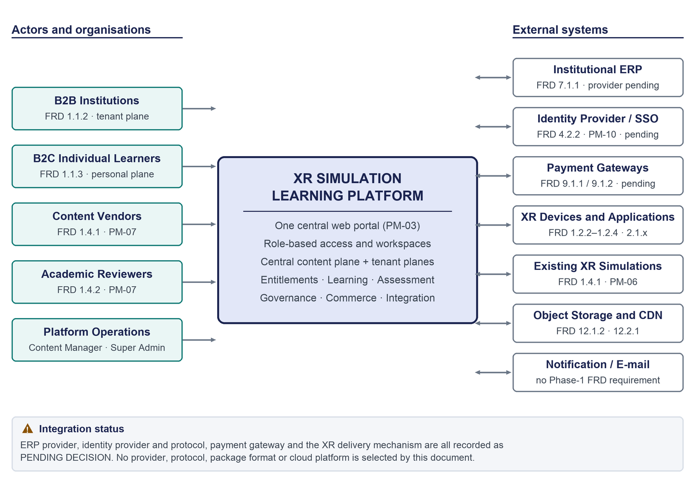
Figure 2 — System context — actors, external systems and integration boundaries
Four of these integrations have no selected provider: the institutional ERP, the identity provider, the payment gateway and the mechanism that gets an experiment onto an XR device. Two more are concepts without a chosen technology: encrypted asset storage and content distribution. Notification appears for completeness only — the word appears once in the original FRD, in a Phase-3 requirement, so there is no Phase-1 notification requirement to build against.

6.2 Roles and workspaces
One platform, one shell, seven role-based areas. What differs between them is the navigation content and the permitted actions, not the surrounding interface.
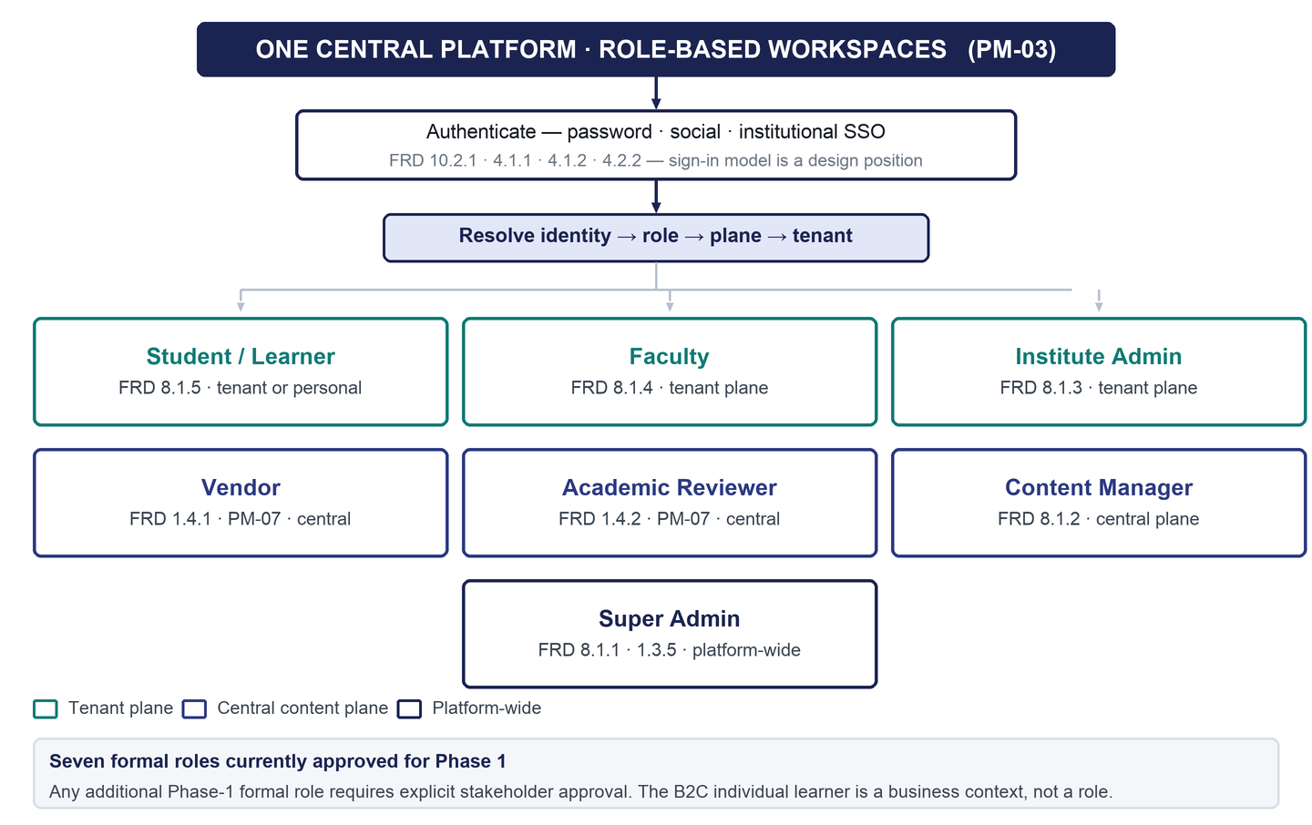
Figure 3 — Role and workspace architecture — one portal, seven workspaces
What is confirmed here, and what is a design position
• Confirmed: one central platform and portal, with role-based access and role-based workspaces; and institutional single sign-on is required.
• Design position, not confirmed: a single shared shell, a single sign-in entry point for all roles, and resolving role from the authenticated identity rather than asking for it before sign-in. These are reasonable and internally consistent, but no source states them.
• Not assumed either way: whether one person may hold more than one role. If multi-role identities are later approved, a workspace chooser is available as a conditional pattern. None is mandated.

6.3 The two planes
The platform has two distinct areas, and one role spans them. Content is made and governed centrally; institutional data is isolated per institution. This was the largest structural unknown in the re-audit, and PM-13 confirmed it.
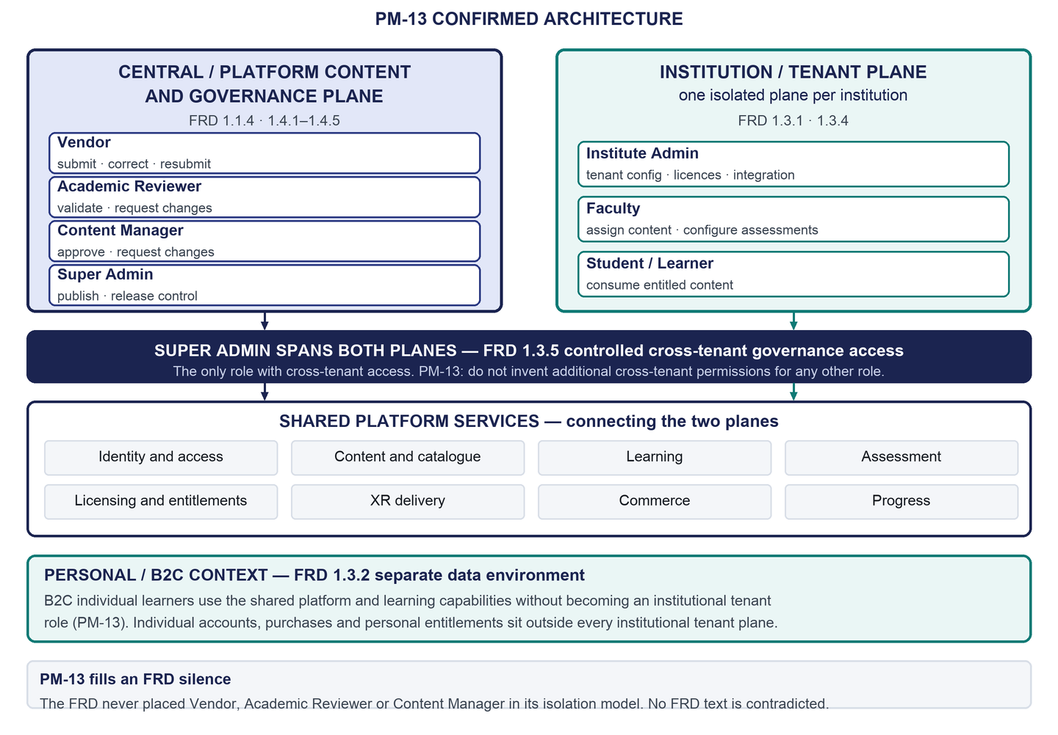
Figure 4 — Two-plane platform architecture confirmed by PM-13
Table 10 — Which roles sit where
Plane | Roles | What lives here | Basis
Central content and governance | Vendor, Academic Reviewer, Content Manager, Super Admin | Module builds, assets, metadata, validation, approval, publication, review history | FRD 1.1.4, 1.4.1–1.4.5; PM-13
Institution / tenant | Institute Admin, Faculty, Student / Learner | Institutional users, entitlements, course structure, progress, licences, tenant-scoped status | FRD 1.3.1, 1.3.4; PM-13
Personal / individual | Student / Learner in the individual context | Individual accounts, purchases, personal entitlements, personal device binding | FRD 1.3.2; PM-13
Spans everything | Super Admin only | Publishing, licensing, platform configuration, cross-institution operational oversight | FRD 1.3.5

The rule that follows is short: the three content-side roles never touch institutional data, so they need no access to it and hold none. Only the Super Admin crosses institutions, and the FRD limits even that to governance and operational oversight.

6.4 Logical platform architecture
The layering below describes responsibilities, not deployment. It is drawn so that an engineering team can choose a technology stack without any statement in this document becoming false.
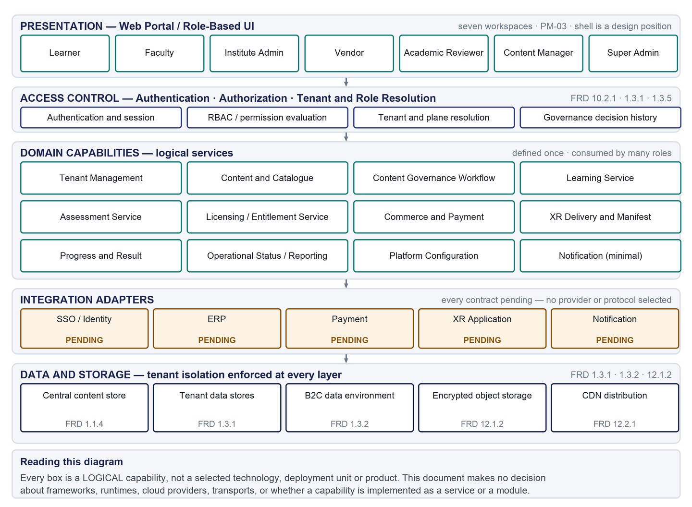
Figure 5 — Logical application and service architecture — technology-neutral
The two capabilities most worth designing once and reusing are licensing and entitlements, which every consumption path depends on, and the content governance workflow, which is the most precisely specified area in the original FRD and had no design at all.

7. Role Model
Seven roles are approved for Phase 1. Five come from the original FRD's own role hierarchy. Two — Vendor and Academic Reviewer — appear in the FRD only as actors in the content workflow, with no role definition and no permissions; PM-07 makes both first-class roles with logins and their own workspace. That is an extension of the FRD and is recorded as one.
On adding roles
• Seven formal roles are currently approved for Phase 1. Any additional Phase-1 formal role requires explicit stakeholder approval. The FRD's own mechanism for defining custom roles is a Phase-3 requirement, so there is no Phase-1 route to add one.
• The individual learner is a business context around the Learner role, not a separate role. External systems are integrations, not roles.

Table 11 — The seven roles at a glance
Role | Purpose | Main responsibilities | Key permissions | Boundaries
Student / Learner  FRD 8.1.5 | Work through entitled content and see own progress. | Complete resources, simulations and assessments in the defined order; reach XR simulations on a supported device; in the individual context, buy and manage own access. | View and consume entitled content; attempt assessments; view own results, attempts and progress; edit own profile; individually: purchase, view bound devices, request a device replacement. | Never authors or configures an assessment. Never sees another learner's data. No content modification. No purchase prompt in the institutional context.
Faculty  FRD 8.1.4 | Assign content, own assessment setup, and see who is stuck. | Assign courses and modules to learners and groups; source questions; define and configure assessments; monitor operational learner status. | Assign content; upload question banks; generate questions with integrated AI tools; configure assessment types, rules and parameters; view learner results within the institution. | No course creation (Phase 2). No content editing. No aggregated class performance reports (Phase 2). Never crosses the institution boundary.
Institute Admin  FRD 8.1.3 | Run the institution's side of the platform. | Register and configure the institution; configure single sign-on and the ERP connection; manage student access and stream-to-package mapping; watch licence seat use. | Manage institutional configuration; configure SSO for the institution; configure ERP and its schedule; manage student accounts and access; map streams to licensed packages; view licences, seat use and operational status. | No device registration or remote device management (Phase 2). No usage dashboards or adoption reports (Phase 2). No course authoring (Phase 2). No content modification. Never crosses the institution boundary. Not automatically granted assessment authoring.
Vendor  FRD 1.4.1 and 1.4.5 as an actor | Supply XR experiments for review, and fix them when they come back. | Create submissions and upload builds, assets and metadata; read reviewer comments; correct and resubmit. | Create and submit; create and edit own submission metadata; edit and resubmit own returned submission; view own submissions, their position in the chain and their review history; view own published modules. | Can never publish — this is the FRD's only explicit role prohibition. No visibility of any other vendor's work. No validation or approval authority. No institutional access at all.
Academic Reviewer  FRD 1.4.2 as an actor | Decide whether an experiment teaches the right thing. | Review submitted content, metadata and documentation; assess alignment with engineering curriculum standards; record a decision with reasons. | Review submissions in the validation queue; record academic validation; request changes with comments and a stated reason; view review history. | Never publishes. Never approves content readiness — that is a different gate. Cannot move work past their own gate. No institutional access. No content editing.
Content Manager  FRD 8.1.2 and 1.4.3 | Check the files and details, then hand cleared content on. | Review metadata, documentation and platform compatibility; read the academic decision as input; record a decision; maintain module metadata. | Review at the readiness gate; edit and maintain module metadata; approve readiness; request changes with comments and a stated reason; view the content library by gate position; view review history. | Never publishes. Cannot alter the academic validation record. No institutional access. No entitlement, licensing or institution-configuration authority.
Super Admin  FRD 8.1.1 and 1.3.5 | Publish content, manage licensing, configure the platform. | Publish approved modules and control version releases; manage institutional and individual licensing; assign platform roles and configure the platform; approve device-replacement transfers; exercise controlled cross-institution oversight. | Publish to production — exclusive; control version release; manage licensing; approve device replacement; configure the platform and assign platform roles; controlled access across institutions for governance and operational oversight. | No custom role creation (Phase 3). No cross-institution analytics dashboards — detailed metrics are deferred. No bundle creation or pricing configuration (Phase 2). Cross-institution access is limited by the FRD to governance and operational oversight.

Every permission above is derived from explicit FRD text or an explicit stakeholder statement. Where neither source defines a permission it is recorded as pending rather than inferred. The full role-by-role definition, including data visibility, workflows, traceability, acceptance criteria and unresolved details, is in the Detailed Requirements and Traceability Reference.

8. Functional Capability Summary
The original FRD's 131 requirements are grouped here into the capabilities they describe. This is the same content organised for reading rather than for tracing. Every requirement identifier, with its faithful original wording, both its phases, its classification and its acceptance criterion, is in the Detailed Requirements and Traceability Reference.
Table 12 — Capabilities and their Phase-1 position
Capability | What Phase 1 requires | Requirements | What is still open
Identity and access | Individual self-registration and social sign-in; institutional accounts provisioned from the ERP; institution-configured single sign-on; profiles; secure authentication; sessions that expire without destroying unsaved work | 4.1.1, 4.1.2, 4.2.1, 4.2.2, 4.3.1, 7.2.2, 10.2.1, 10.2.2, 7.4.1 | Provider and protocol for SSO; password, multi-factor and lockout policy; how a person becomes Faculty or Institute Admin in Phase 1; the sign-in model itself
Tenancy | Each institution's data logically isolated; individual data in a separate environment; reporting confined to one institution; controlled cross-institution access for the Super Admin alone | 1.1.1, 1.1.2, 1.3.1–1.3.5 | How the planes are physically separated; whether one person can hold both an institutional and an individual identity
Content and catalogue | A module is one simulation; courses group modules; modules may carry resources and an assessment; only published content is visible; all content stays centrally owned | 1.1.4, 1.4.4, 3.1.1, 3.1.2, 3.2.1, 3.2.2 | The metadata schema reviewed at the readiness gate; whether the certification structure node is still modelled
Learning | Resources, then simulation, then assessment, then completion; courses define the module order; completion is recorded against the account | 3.1.2, 3.2.2, 8.1.5, 11.1.1 | Whether the sequence is configurable per course; who owns captions and transcripts
Assessment | Faculty or the authorised institution side owns setup; question banks by spreadsheet and by AI generation; multiple-choice, true/false and short descriptive questions; configurable rules; results and attempts recorded | 5.1.1, 5.1.2, 5.2.1–5.2.3, 5.3.1, 5.3.2, 11.2.1, 11.2.2 | Who grades descriptive answers; post-attempt feedback and answer-key policy; single or multi-select; the configuration API contract; whether hints are in scope at all
XR delivery | Four formats — browser, VR headset, MR device, mobile AR; an entitled experiment must be able to become available on the device that runs it; entitlement checked before delivery and again before execution; assets encrypted and distributed with acceptable latency | 1.2.1–1.2.4, 2.1.1, 2.1.2, 2.2.1, 2.2.2, 2.3.1–2.3.3, 2.4.1–2.4.4, 10.1.1, 10.1.2, 12.2.1 | The delivery mechanism itself — deliberately unselected; no AR application architecture exists in the FRD; the package format; device sign-in under SSO; what happens when a completion is never recorded
Licensing and entitlements | Institutional licences mapped to academic streams and capped by student count; individual module and bundle purchase; automatic licence activation; entitlement assignment; individual licences bound to a device | 6.1.1, 6.1.2, 6.2.1, 6.2.2, 7.2.3, 9.2.1, 9.2.2, 2.4.1, 2.4.2 | How an institutional licence is transacted in Phase 1, since institutional billing is Phase 2; how extra seats are obtained
Commerce and payments | Individual catalogue browsing and purchase; domestic and international gateway integration; success, decline and indeterminate outcomes all handled | 1.1.3, 6.1.1, 6.1.2, 9.1.1, 9.1.2 | The gateway itself; currency, tax and price presentation; refund and cancellation rules; the receipt format; who creates bundles and sets prices in Phase 1; whether direct course purchase is in scope
Content governance | Vendor submits; academic validation; content readiness approval; Super Admin publishes; vendors never publish; either reviewer may send work back with reasons; the vendor corrects and resubmits; every decision is traceable | 1.4.1–1.4.5, 2.3.2 | The curriculum standards validated against; the submission package format; whether the Super Admin may also send work back; whether a resubmission restarts or resumes
ERP and SSO integration | ERP integration by standard API; scheduled synchronisation at an institution-set interval; automatic student account creation; stream-based access assignment; institution-configured single sign-on | 7.1.1, 7.1.2, 7.2.1–7.2.3, 4.2.2, 7.4.1 | Providers and contracts on both sides; which profile fields the ERP owns and which the user may edit; whether the learner is told when access changes
Progress | Module completion, time spent, assessment scores and attempt counts all recorded; the learner sees their own; Faculty and Institute Admin see operational status within their institution | 11.1.1, 11.1.2, 11.2.1, 11.2.2 | How time spent is presented; reporting granularity
Operational reporting | Current-state operational views only: who is blocked, how many seats are in use, what is in the review queue, what is awaiting publication | 8.1.1, 8.1.3, 8.1.4, 1.3.4 | All detailed metrics, formulas, filters and KPI definitions — deferred by instruction
Security and audit | Assets encrypted before distribution and at rest; licence validation before execution; secure authentication; session expiry; periodic penetration testing and patching; content governance decisions traceable | 10.1.1, 10.1.2, 10.2.1, 10.2.2, 10.3.1, 10.3.2, 12.1.2 | Any audit trail outside content governance — licensing, entitlements, configuration, device replacement
Platform configuration | Platform-wide settings and role assignment; version release control; institutional configuration; SSO and ERP configuration; assessment configuration | 8.1.1, 2.3.2, 8.1.3, 4.2.2, 7.2.1 | The hosting platform and environment topology

Two additions worth naming explicitly
• Ten requirements are new, arising from stakeholder decisions rather than the original FRD: the seven-role model, the Vendor and Academic Reviewer workspaces, the two-plane model, sending content back with reasons, correction and resubmission, review history, entitlement-aware device delivery, mechanism neutrality, and the requirement to produce the platform architecture before detailed design.
• Twelve existing requirements are clarified rather than changed — how they are now read, and by whose authority. All twenty-two are set out with identifiers in the Detailed Requirements and Traceability Reference.

9. Key End-to-End Workflows
Six workflows carry most of the platform. Each is described as what must happen, in order. Where a mechanism has not been chosen, the step says what has to be true and stops there — that is a record of an open decision, not a gap. Four further workflows, and the full step-by-step detail, are in the Detailed Requirements and Traceability Reference.

9.1 Content to production
The most precisely specified sequence in the original FRD, and the one that had no design at all because three of its four actors were outside the earlier scope.
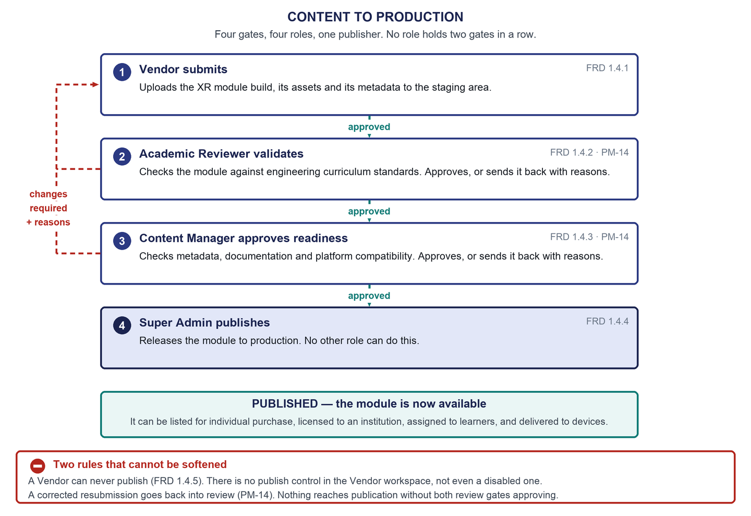
Figure 6 — Content to production — four gates, four roles, one publisher
Three approvals, three different roles, one publisher, and no role holds two gates in a row. A reviewer can send work back but can never send it forward past their own gate, and sending work back does not confer any publishing authority. Everything the vendor needs to act on — where the submission is, and why it came back — is visible to them throughout.

9.2 Institutional learning
Table 13 — Institutional route, end to end
Step | Who | What happens
1 | Super Admin / Institute Admin | An institutional licence exists against the institution: packages mapped to academic streams, capped by student numbers. How this is transacted in Phase 1 is undecided, because institutional billing is Phase 2.
2 | Institute Admin | Configures the ERP connection and its schedule, configures single sign-on, and maps academic streams to the licensed packages.
3 | Platform | Scheduled synchronisation brings student records in; accounts are created and stream-based access is assigned. Entitlements exist before a learner first signs in.
4 | Faculty | Reviews the course structure that arrived from the ERP, assigns content to learners and groups, and configures the assessments.
5 | Learner | Signs in and reaches their entitled content. Institutional single sign-on is required and available per the institution's configured authentication model.
6 | Learner | Works through resources, simulation and assessment; the module completes and the next one unlocks.
7 | Faculty / Institute Admin | See operational status within their own institution — who has completed, who is blocked, how many seats are in use. Aggregated performance reporting is Phase 2.

- If the licence cap is reached, the learner is blocked with an explanation directing them to their institution and no purchase prompt. The Institute Admin can see seat use before that happens.
- If no access has been assigned, the learner sees an empty state that explains the institution assigns access, rather than an unexplained blank list.

9.3 Individual purchase to learning
Table 14 — Individual route, end to end
Step | What happens
1 | The learner registers themselves by e-mail or a supported social sign-in. Their account sits in the separate individual data environment.
2 | They browse the catalogue of published modules and bundles. Phase-1 purchase requirements name modules and bundles; direct course purchase is not specified.
3 | They view a product and check out. Access duration is shown only where authoritative data exists.
4 | Payment runs through a gateway. No provider is selected. Success, decline and indeterminate outcomes are each handled.
5 | The licence activates automatically and the entitlement is assigned. The content is immediately reachable.
6 | They reach the simulation — in the browser, or on a supported device. Individual licences are bound to a device and account.
7 | They work through resources, simulation and assessment; the module completes. Progress is personal; there is no oversight role in this context.

9.4 Assessment configuration to result
The learner-facing half of this was already designed. The authoring half did not exist. What changed in the learner-facing half is where its numbers come from — every displayed value is now read from the assessment's configuration. Chapter 11 sets out the model and shows the flow.

9.5 XR entitlement and device delivery
The product requirement is confirmed and the mechanism is deliberately not chosen. This workflow therefore specifies the lifecycle and the states a learner must be able to perceive, and names no transport, protocol, package format or endpoint. Chapter 10 sets it out.

9.6 Single sign-on and ERP integration
Table 15 — The institution's integration setup
Step | Who | What happens
1 | Institute Admin / Super Admin | The organisation is registered and its isolated environment is created.
2 | Institute Admin | Configures single sign-on with an identity provider and tests the connection before enabling it. Provider, protocol and attribute mapping are undecided.
3 | Institute Admin | Configures the ERP connection and the synchronisation interval. Provider and contract are undecided.
4 | Platform | Each scheduled run validates incoming records before changing anything, creates accounts, assigns stream-based access, and keeps failed records with a reason so they can be retried.
5 | User | Signs in. The platform resolves identity, institution and role, and the user reaches their area of the platform.
6 | Institute Admin | Sees the last run, its outcome, its counts and its errors as operational status.

Two collisions recorded here
• The FRD requires institutional students to sign in to the XR application with their LMS credentials, and also requires institutional single sign-on. A learner authenticated by single sign-on may have no password to type into a headset. Both are Phase-1 requirements and they conflict; the conflict is recorded, not designed around.
• The ERP is authoritative and scheduled synchronisation will overwrite local edits, yet the FRD also has users supplying profile details. Which fields the user may edit is undecided; the working position is that ERP-sourced fields are shown read-only with their origin stated.

10. XR Delivery Model
An experiment a learner is entitled to must be able to become available on the device that runs it. That is confirmed, and it is already implied by the original FRD: modules download only after licence validation, and require licence validation before they execute. What was missing was any designed experience for it.
Table 16 — The four formats
Format | Runs on | What the FRD says about the application | Portal can run it?
Web | A standard browser, no XR hardware | Not applicable — it runs in the portal | Yes
VR | A VR headset | A centralized VR application acting as the container for downloading and launching modules | No
MR | An MR device | An application sideloaded onto the device | No
AR | Android and iOS phones | Nothing. The FRD defines no application architecture for AR at all. | No

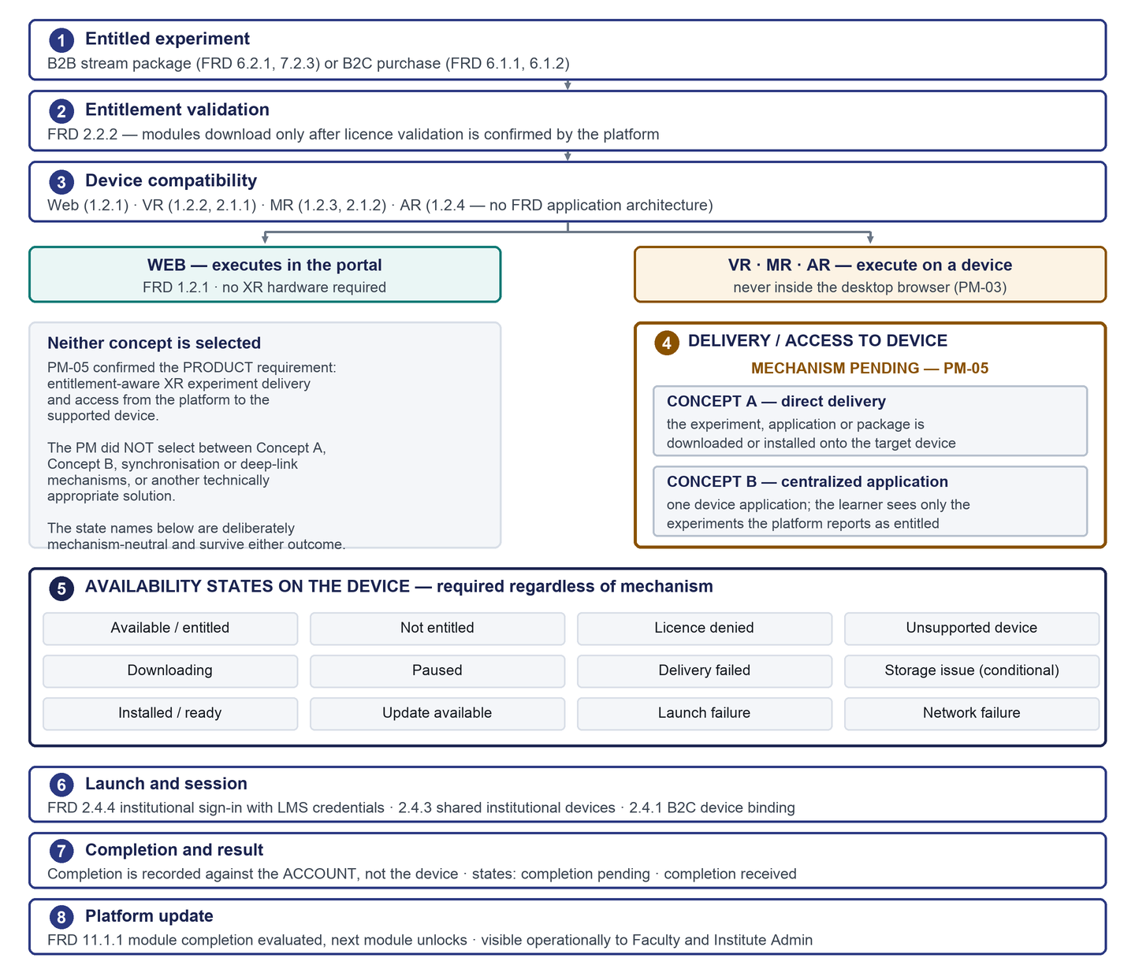
Figure 7 — FLOW 5 — XR entitlement and device-delivery lifecycle

10.1 The two concepts, neither chosen
Table 17 — What was described
Concept | What it means | How it relates to the FRD
A — direct delivery | The experiment, application or package is downloaded or installed onto the device. | Partly supported. The FRD packages modules as encrypted bundles but describes them as downloaded *by a master application*, which is the other concept's framing. Whether an experiment can be installed without a container application is never stated.
B — centralized application | One application on the device holds the experiments, and the learner sees only those the platform reports as entitled. | Strongly supported for VR: the FRD describes exactly such a container, has it downloading bundles, updates modules without reinstalling it, and has the learner signing in to it. Whether MR and AR follow the same pattern is not stated.
Other | Synchronisation, a deep-link handoff, or another appropriate solution. | Left explicitly open.

The honest position
• The FRD leans toward the centralized-application concept for VR. That is a fact about the FRD, not a stakeholder choice.
• MR uses a different distribution model, AR has no application architecture at all, and direct delivery remains explicitly on the table. No selection is made here.
• Every state name in this document is chosen to survive either outcome. “Ready on your device” works for both; “downloaded” presumes one and “unlocked in the app” presumes the other, so neither is used.

10.2 The states a learner must be able to see
These hold regardless of mechanism, which is what lets the learner-facing experience be designed now.
Table 18 — Required states
Group | States
Entitlement | Available and entitled · not entitled · licence denied · licence cap reached
Device | Unsupported device · downloading · paused · installed and ready · update available
Failure | Delivery failed · network failure · launch failure · storage issue (only if the chosen mechanism makes it possible)
Completion | Completion pending · completion received

- The portal never offers a control it cannot honour. If the portal cannot launch something, it does not show a launch button.
- Waiting is designed, not incidental. Content-distribution latency and bundle size make preparation time real.
- Entitlement is checked twice and both checks are visible. A learner can pass the first and fail the second, and that must not read as a defect.
- Completion belongs to the account, not the device. The portal reflects account state; it does not watch the session.
- AR is not assumed to behave like VR. The gap is flagged, not filled.
The remaining gaps in this area are the delivery mechanism, the absent AR application architecture, the package format, whether browser simulations use the same licence-validated path, how a device sign-in works for a learner authenticated by single sign-on, and what happens when a completion is never recorded. All six are in the open-question register; full detail is in the Detailed Requirements and Traceability Reference.

11. Assessment Model
The two governing positions
• Assessment behaviour is configured through the portal and consumed by the relevant browser or XR application through flexible APIs.
• For both institutional and individual learners, assessment setup is owned by Faculty or the authorised institution side. A learner never authors or configures an assessment.

This is a correction of interpretation, not of requirement. The original FRD states no question count, no duration, no score weighting, no pass mark and no attempt limit anywhere in its seventeen pages. What it does state is configurability: faculty upload question banks, questions *may* be randomised, and faculty *shall be able to enable* negative marking. Any specific numbers that appeared in earlier prototype work are sample configuration and never platform constants.
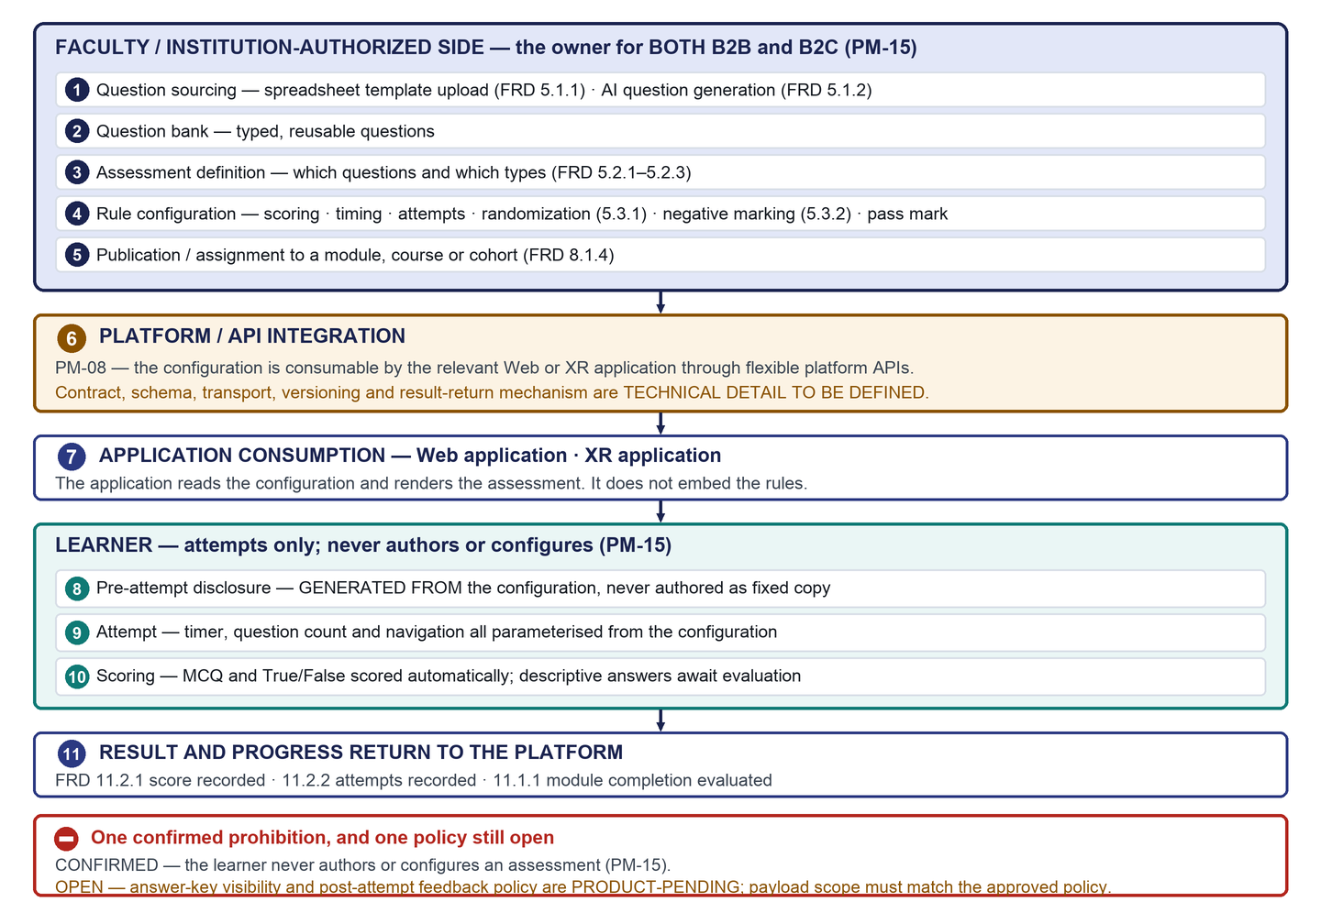
Figure 8 — FLOW 4 — assessment configuration to result

11.1 Question types
Table 19 — What the FRD supports
Type | Scored automatically | Note
Multiple choice | Yes | Single-select or multi-select is not stated. Multi-select would need a partial-credit rule that no scoring model defines.
True / false | Yes | No open questions.
Short descriptive answer | No | No requirement says who grades these, on what turnaround, or against what rubric — and completion gates the next module, so an ungraded answer can strand a learner.

No other question type exists in the FRD and none is invented here. Simulation-based performance scoring is a Phase-2 requirement.

11.2 What is configurable, and what is still a decision
Table 20 — Configuration fields by evidentiary strength
Strength | Fields
Clearly implied by the FRD | Which question types are enabled · which question bank and questions · question randomisation · negative marking on or off · what the assessment is assigned to · recording of scores and attempts (always on)
Needed by the model, no approved value | Question count · time limit · timing model · score for correct, incorrect and unanswered · pass threshold · attempt limit · score floor. Every one of these is sample configuration — no specification, screen or handoff may present any value as a default or a recommendation.
Optional and unapproved | Hints, hint scoring and hint limits. No source defines hints: the FRD does not mention them and PM-08 confirms configurable assessment behaviour without naming them. Classified OPTIONAL / PRODUCT-PENDING, and no hint behaviour is assumed in either direction.
Needs a decision before it can be a field | Who grades descriptive answers · post-attempt feedback and answer-key policy · single or multi-select · extended-time accommodation and who grants it · whether the Institute Admin holds any assessment authority · whether a configuration is reusable across courses or institutions · whether a configuration may change between attempts

11.3 Feedback policy is open
Answer-key visibility
• Answer-key visibility and post-attempt feedback policy are undecided. No requirement in the original FRD and no stakeholder decision states what feedback a learner may see after an attempt.
• Whatever policy is approved, the contract must honour it: a learner-facing application must receive only the assessment data that policy permits. Displayed scope and payload scope have to match, because a response body is one browser developer-tools tab away from being read.
• This is recorded so the policy is decided deliberately rather than settled by whatever the first payload happens to contain.

11.4 What this means for the interface
- The pre-attempt disclosure has to be generated from the configuration, not written as fixed copy. If a configuration turns negative marking off, fixed copy that mentions it would be untrue.
- Layouts have to tolerate variation — five questions or fifty, five minutes or none, a pass threshold of 40 per cent or 80. Fixed-count navigators and hard-coded maxima break.
- The structure of the existing learner assessment screens does not change. Where their numbers come from changes completely.
The configuration schema and the platform-to-application API contract are both undecided: endpoint, transport, payload shape, field names, authentication, versioning and whether results return synchronously are all open.

12. Institutional and Individual Models
Both are Phase 1 and neither is sequenced ahead of the other. The two routes share one learning experience and differ only where the FRD makes them differ.
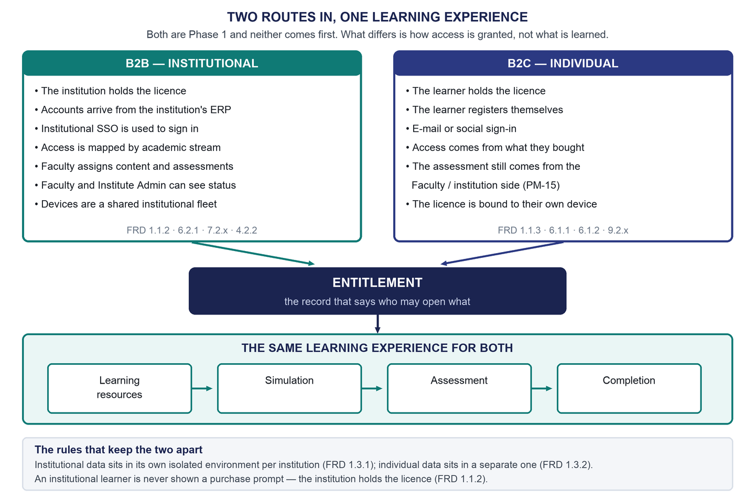
Figure 9 — Two routes in, one learning experience — B2B and B2C converging on one entitlement
The asymmetry in the work is not between the two markets. It is between the learner and everyone else: both learner journeys were in reasonable shape, and what was missing was the institutional machinery behind the institutional one — because the roles that operate it were outside the earlier scope.

13. Commerce, Licensing and Entitlements
Licensing and entitlements is the structural spine of the platform. Learning reads it, XR delivery validates against it twice, commerce creates it, the ERP populates it, and tenancy scopes it. Two origins produce the same object, and that object is what a learner consumes.
Table 21 — What Phase 1 requires
Area | Required | Undecided
Individual purchase | Individual module purchase; bundle purchase; domestic and international gateway integration; automatic licence activation on payment; entitlement assignment; licences bound to a device | The gateway; whether checkout is single-item or basket-based; currency, tax and price presentation; refund and cancellation rules; the receipt format; who creates bundles and sets prices in Phase 1; whether direct course purchase is in scope at all
Institutional licensing | Packages mapped to academic streams; licences capped by student count; seat use visible to the Institute Admin before exhaustion; stream-to-package mapping; access granted and revoked within the institution | How an institutional licence is transacted in Phase 1, since institutional invoicing and subscription billing are Phase 2; how extra seats are obtained
Entitlement enforcement | Checked at browse and before delivery; checked again before execution; checked against the seat cap; meaningful only within its own institution or personal context | Nothing outstanding — this is the best-specified part of the area

What this chapter does not decide
• No payment provider is selected, for either the domestic or the international requirement.
• No currency, tax, refund, cancellation or invoicing rule is stated. These are compliance-adjacent and remain open.
• Direct course purchase is not specified and is not included in the current design unless subsequently approved. It is neither required nor prohibited by any source.

14. Single Sign-On, ERP and External Integrations
Institutional single sign-on is required, and is available according to the institution's configured authentication model. This resolves a contradiction inside the original FRD, which places SSO configuration in Phase 1 and SSO authentication support in Phase 3. The requirement is a configuration capability, not just a login button — an institution needs somewhere to configure it, test it and enable it, and that surface had never been designed.
ERP integration follows the same pattern: every ERP capability has a learner-visible consequence that was already designed and an administrator-facing control that was not. Scheduled synchronisation at an institution-set interval implies a place to set that interval and see how the last run went.
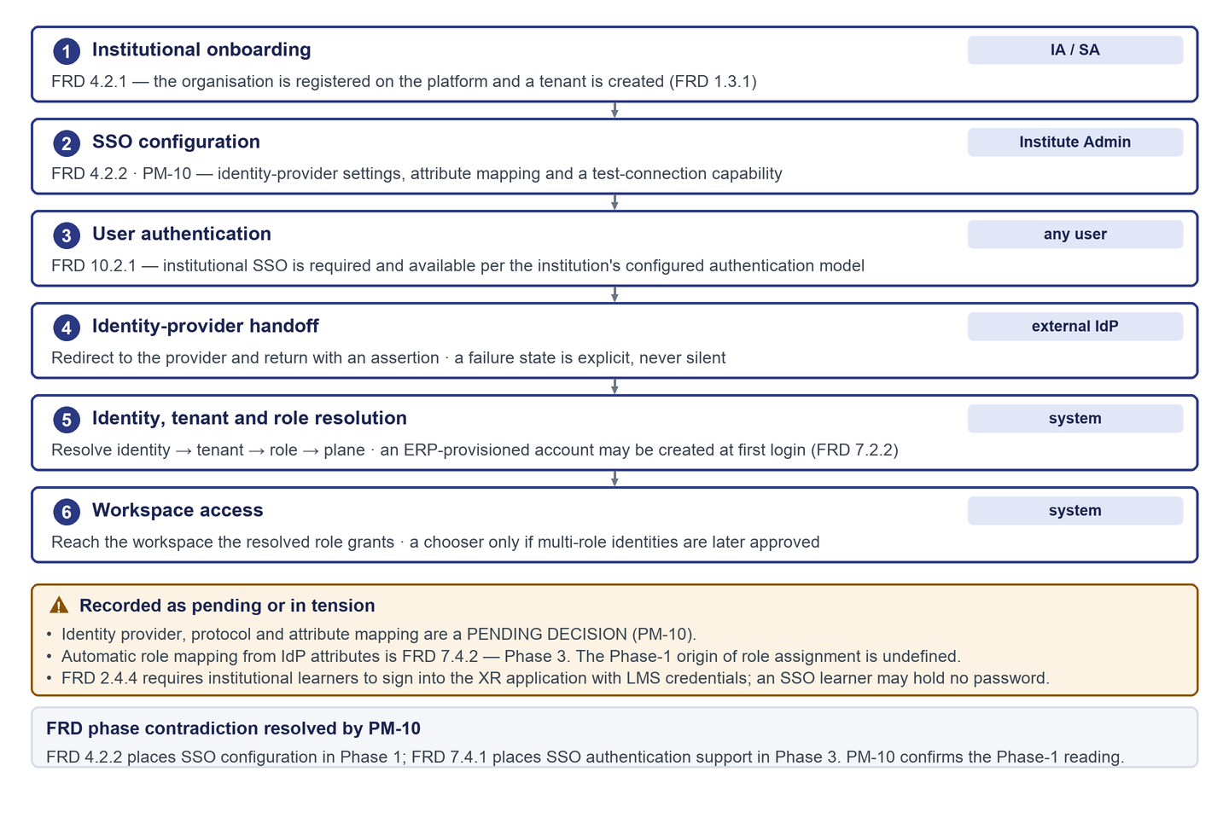
Figure 10 — FLOW 6 — institutional SSO, tenant and role resolution
Table 22 — Integration boundaries
Integration | What crosses it | Status
XR application | Entitlement state outward; completion and result inward | Mechanism deliberately unselected
Assessment consumption | Assessment configuration outward; attempt result inward | Schema, transport and versioning undecided
Payment gateway | Transaction request outward; outcome inward | No provider selected
Identity provider | Authentication request outward; assertion inward | No provider or protocol selected
ERP | Enrolment, course mapping and academic structure inward | No provider or contract selected
Storage and content distribution | Encrypted asset bundles outward to devices | Technology not selected
E-mail and notification | Outbound messages | No Phase-1 requirement exists. In-workflow status is specified instead

Every one of these is a contract to be defined, not a product that has been chosen. This document names no provider, protocol, endpoint or payload format for any of them.

15. Security and Data Boundaries
Four boundaries are stated by the original FRD in unambiguous terms. They are not design preferences, and they have to survive into every screen and every interface.
- Only the Super Admin publishes. No other role holds publishing authority in any state.
- Vendors can never publish. This is an explicit prohibition, not merely an absent permission, and it is expressed positively — a vendor sees where their submission is, never a disabled publish control, because a disabled control implies a permission that will never exist.
- Reporting never crosses an institution, except through the controlled oversight the FRD grants to the Super Admin alone.
- Institutions cannot modify or redistribute content. All content stays under the platform owner's ownership and governance.
Table 23 — The rest of the security position
Area | Required | Note
Data isolation | Institutional data logically separated per institution; individual data in its own environment | How the separation is implemented is an engineering decision
Least privilege | Every permission derives from explicit FRD text or an explicit stakeholder statement | Where neither defines a permission it is recorded as pending, never inferred
Asset protection | Bundles encrypted before distribution and stored encrypted | No workspace offers a route to an unprotected copy
Licence validation | Before delivery and again before execution | Two gates, both visible to the learner
Auditability | Content governance decisions, comments, returns and resubmissions are traceable | Audit outside content governance is undefined and is not invented — licensing, entitlements, configuration and device-replacement decisions have no defined trail
Authentication and sessions | Secure authentication for every role; sessions expire without destroying unsaved work | Password, multi-factor and lockout policy are absent from the FRD and are recorded as pending rather than invented
Testing and patching | Periodic vulnerability assessment and penetration testing; timely patching | Neither period nor response time is quantified anywhere, and no number is invented

Non-functional targets — availability, performance, backup, retention, accessibility conformance — are recorded as requirement categories with their target status. No numeric target is invented anywhere in this document set. The full list of eighteen categories is in the Detailed Requirements and Traceability Reference.

16. Reporting Strategy
Core functionality and operations come first. Detailed reporting and analytics parameters are added incrementally once the underlying functionality and the available data are understood. This agrees with the original FRD's own phasing rather than departing from it: every Phase-1 analytics requirement in the FRD is a recording requirement, and every dashboard requirement sits in Phase 2 or Phase 3.
Table 24 — The test applied to every proposed Phase-1 reporting element
The question it answers | Classification | Phase 1?
What is the state of the thing I operate right now? | Operational | Yes
Which of my learners are blocked today? | Operational | Yes
How many seats of our licence are in use? | Operational | Yes
What is in my review queue? | Operational | Yes
How is this cohort performing over the semester? | Analytical | No — Phase 2
What is our module adoption trend? | Analytical | No — Phase 2
Where do learners make mistakes inside a simulation? | Analytical | No — Phase 3

Phase 1 therefore records module completion, time spent, assessment scores and attempt counts, and presents them as current-state operational views appropriate to each role — bounded, in every case, to one institution. No detailed dashboards are designed and no metric definitions, formulas or filters are invented. They remain open by instruction, and reporting is not removed from the long-term requirement set.

17. UI/UX Direction
The order of work is set: complete platform sitemap, then role permissions, then workflows for all roles, then the most important end-to-end flows into detailed design. Detailed interface work does not begin for a flow before its position in the sitemap, its permission set and its workflow have been recorded and reviewed. Which flows go first is a stakeholder selection that has not yet been made.
Table 25 — Interface direction
Principle | What it means | Status
One platform, seven areas | The same header, account menu, component set and state language everywhere. What differs is the navigation content and the permitted actions. | Design position
Role-based navigation | Each area exposes only its own capabilities. Anything belonging to a later phase is absent, not shown greyed out. | Requirement-based
Prohibitions shown positively | A vendor sees where their submission is, never a disabled publish control. | Requirement-based
Shared surfaces are shared components | One read-only module viewer used by five roles in permission-filtered contexts; one state vocabulary; one shell. | Design position
Institution boundaries are structural | No institution switcher exists for institution-side roles. Only the Super Admin crosses, through an explicit institutional context. | Requirement-based
Sign-in model | One entry point, with role resolved from the authenticated identity rather than chosen before sign-in. | Design position — undecided
Workspace chooser | Available as a conditional pattern only if multi-role identities are later approved. None is mandated. | Conditional — undecided
Viewport policy | Administrative work is desktop-typical, but this has to be decided per area rather than inherited from the learner surface. | Undecided

Every state a user can reach has to be a designed state rather than an absence: loading, empty, success, validation error, system error, permission denied, unsupported device, invalid or expired licence, licence cap reached, failed payment, changes required, resubmitted, approved, published, the delivery states, session expiry, awaiting evaluation and synchronisation status. Two rules apply to all of them — each says what happened and what to do next, and none exposes an internal code, identifier or stack trace.
On accessibility: the platform will meet a stated conformance level, the level has to be approved rather than implied, known non-conformances are recorded openly, and meaning is never carried by colour alone. Ownership of video captions and transcripts is undecided, and the position taken here is that an uncaptioned video should not be a required component for completion.

18. Stakeholder-Confirmed Decisions
Fifteen decisions were confirmed directly by the Project Manager — twelve on 18 August 2026 and three on 19 August 2026. They are summarised here because several change the reading, the owner or the phase of requirements in the original FRD, and those changes have to stay visible. The full record of each, with affected requirements, roles, effect and what remains pending, is in the Detailed Requirements and Traceability Reference.
Table 26 — PM-01 to PM-15
ID | Topic | Confirmed statement | Relationship to the original FRD
PM-01 | Current UI/UX and requirement scope | All Phase-1 requirements and all Phase-1 roles are in the current scope. The Student/Learner work remains reusable as one workspace within the complete platform. | Alignment — breadth unchanged, role depth widened
PM-02 | Required design process | Create the complete platform sitemap, role permissions and all-role workflows before taking the most important end-to-end flows into detailed Figma. | Process requirement, not an FRD matter
PM-03 | Platform model | Treat the solution as one central XR Simulation Learning Platform / web portal with role-based access and workspaces. This must not be read as saying every XR runtime executes inside the browser. | Alignment, with an explicit caveat that not every runtime is in a browser
PM-04 | B2B and B2C | Both B2B institutional and B2C individual models are required. B2B-first / B2C-second is not a confirmed release sequence. Both must be represented in the platform architecture. | Alignment — both models are Phase 1 in the FRD
PM-05 | Web portal to XR device delivery | Entitled or subscribed XR experiments must have a mechanism to become available on the supported target device. Two concepts were described and neither was selected: (A) direct experiment, application or package delivery; (B) a centralized XR device application with entitlement-controlled experiments or modules. | Alignment, plus a recorded gap: no AR application architecture exists
PM-06 | XR simulation availability | The required XR simulations and experiments are available. The current platform team is not assumed to build every simulation from scratch. | Alignment
PM-07 | Vendor and Academic Reviewer | Vendor and Academic Reviewer require actual platform logins and workspaces. They are no longer merely external actors. | 🟠 Extension — the FRD defines five roles; these two are actors only
PM-08 | Assessment configuration | Assessment setup must be configurable through the portal and linked to Web and XR applications through flexible APIs. Previous fixed prototype values are sample configuration only. | Alignment — the FRD states no assessment values anywhere
PM-09 | Learning progression | The approved learning sequence is: Learning Resources → Simulation → Assessment → Completion / progression. | Alignment
PM-10 | Institutional SSO | Institutional SSO integration is required. It stays in the platform architecture and in the institutional authentication experience. | ✅ Resolves a contradiction inside the FRD
PM-11 | Reporting and analytics strategy | Build core functionality and operations first. Detailed reporting and analytics parameters will be added incrementally. | Alignment with the FRD's own phasing of dashboards
PM-12 | Certification | Certification is not part of the current Phase-1 product. Certification is a Phase-2 activity. | 🔴 Deviation — the FRD places certification in Phase 1
PM-13 | Platform and tenancy model | Use the confirmed two-plane role model. Central / platform content and governance plane: Vendor, Academic Reviewer, Content Manager, Super Admin. Institution / tenant plane: Institute Admin, Faculty, Student / Learner. B2C learners use shared platform and learning capabilities outside the institutional tenant role model where appropriate. | Fills a silence in the FRD; contradicts no FRD text
PM-14 | Content rejection and resubmission | The content workflow must support approval, changes required or rejection, comments and reasons, Vendor correction, resubmission, and review history and status traceability. | 🟠 Extension — the FRD describes a forward-only chain
PM-15 | Assessment ownership for B2B and B2C | For both B2B and B2C, assessment setup and configuration is owned by Faculty or the authorized institution side. Learners do not author or configure assessments. | Alignment, extended to the individual case the FRD never addressed

The two departures from the FRD, and the two extensions
• 🔴 Deviation — certification. The FRD places certification structure and completion criteria in Phase 1. PM-12 moves both to Phase 2. Recorded, never applied to the original.
• 🟠 Extension — the role set. Vendor and Academic Reviewer become roles with logins and workspaces. The FRD's own mechanism for adding roles is a Phase-3 requirement, so it cannot justify this within Phase 1.
• 🟠 Extension — sending content back. The FRD's governance chain only moves forward. Rejection, comments, resubmission and review history are added, because a gate that can only approve is not a gate.
• ✅ Conflict resolved — single sign-on. The FRD contradicts itself on the phase; the Phase-1 reading is confirmed and the original phase is preserved.

19. Key Changes from FRD v4
What changed relative to the original FRD, and relative to the narrower reading of it. Most entries are clarifications or additions. Only two are deviations from the FRD as written, and both are labelled.
Table 27 — Old position to new position
Area | Previous position | Updated position | Type
Scope | Detailed Phase-1 scope was the student's desktop experience | All Phase-1 requirements and all Phase-1 roles | Clarification
Role model | Five FRD roles, one in design scope | Seven roles, each with its own area | 🟠 Extension
Vendor | An external actor with no login or permissions | A role with a workspace: submit, correct, resubmit, track | 🟠 Extension
Academic Reviewer | An external actor with no login or permissions | A role with a workspace: validate, request changes, decision history | 🟠 Extension
Tenancy | The content-side roles were unplaced in the isolation model | A confirmed two-plane model; the Super Admin alone spans it | Fills a silence
Markets | An institution-first order had entered the work as an assumption | Both are Phase 1; neither is sequenced first | Clarification
XR access | XR formats were surfaced as device guidance only | Entitlement-aware delivery to the device, with a full state model | Alignment + gap
XR content origin | Unclear whether the team must build the simulations | The simulations exist; the platform ingests, governs and delivers them | Clarification
Assessment values | Specific numbers treated as platform constants | A configuration-driven model; earlier numbers are sample configuration | Clarification
Assessment ownership | Undefined for an individual learner | Faculty or the authorised institution side, for both markets; a learner never configures | Clarification
Learning progression | A design proposal | Approved: resources, simulation, assessment, completion | Clarification
Content governance | A forward-only chain | Return loops at both review gates, with comments, resubmission and a traceable history | 🟠 Extension
Single sign-on | The FRD contradicted itself on the phase | Required, including the institution-side configuration surface | ✅ Conflict resolved
Reporting | Risked being inferred as large administrative dashboards | Operations first; analytics added incrementally | Alignment
Certification | Phase 1 in the FRD | A Phase-2 activity | 🔴 Deviation
Architecture | No consolidated platform architecture existed | System context, roles, two planes, capabilities, logical services, security boundaries | New
Workflows | Existed for one role's journeys | Ten cross-role workflows covering all seven roles | New
Registers | Questions and dependencies were implicit or single-role | Open-question, dependency, acceptance-criteria and traceability registers | New
Accuracy | Seven claims asserted more than the sources support | Corrected and reclassified; three new open questions recorded | Correction

20. Open Questions
Table 28 — Open questions by class and priority
Class | Blocker | High | Medium | Low | Total
Product | 0 | 3 | 14 | 7 | 24
Technical | 0 | 4 | 9 | 2 | 15
Data / Integration | 0 | 2 | 6 | 2 | 10
Design | 0 | 3 | 6 | 1 | 10
Total | 0 | 12 | 35 | 12 | 59

There are no blocking questions
• No open item prevents the platform architecture, the role and permission model, the capability map or the workflow set from being completed. That is stated deliberately — calling something a blocker when work can continue is as damaging as missing a real one.
• Several questions do block development of a specific capability. Each is marked individually in the register.
• Nineteen further items are recorded as future-phase, so their absence from Phase 1 is understood as scope. Nineteen questions have already been closed by stakeholder decision and are not shown as open anywhere.

20.1 The high-priority questions
Table 29 — All high-priority open questions
ID | Class | Question | Current safe position | Owner
QP-02 | Product | Who grades descriptive answers, on what turnaround, and against what rubric? | The grading queue is named and positioned but explicitly unowned and undesigned. | Project Manager with academic stakeholder
QP-04 | Product | How is an institutional licence transacted in Phase 1, given that institutional billing is Phase 2? | Licences are shown as existing. No in-platform purchase flow is invented. | Project Manager with commercial owner
QP-27 | Product | What post-attempt feedback may a learner see, and is answer-key visibility ever permitted? | No feedback policy is asserted in either direction. Learner-facing applications receive only the assessment data the configured and approved policy permits, and that policy is undefined. | Project Manager with academic stakeholder
QT-01 | Technical | Which XR delivery mechanism is used? | The delivery contract is mechanism-neutral by design and survives any outcome. Pending by explicit instruction. | Team Lead with Project Manager
QT-02 | Technical | There is no AR application architecture in Platform FRD_v4. What is it? | Flagged, not filled. AR is explicitly not assumed to behave like VR. | Team Lead
QT-03 | Technical | What is the assessment configuration API contract? | Abstract. One constraint is recorded now: a learner-facing payload must carry only the assessment data the approved feedback policy permits, and that policy is itself open (QP-27). | Team Lead
QT-04 | Technical | How does an SSO-authenticated learner sign into the XR application, which requires LMS credentials? | Recorded as a collision. Not designed around. | Team Lead with Project Manager
QD-01 | Data | Which profile fields are user-editable and which are ERP-owned? | ERP-sourced fields are presented read-only with their provenance stated. | Team Lead with Institute stakeholder
QD-02 | Data | What is the Phase-1 origin of role assignment? | Super Admin assigns platform roles under 8.1.1. The institutional role-assignment origin is left open rather than invented. | Project Manager with Team Lead
QX-01 | Design | Does the desktop-first viewport decision extend to all six new workspaces? | Not extended automatically. Administrative work is desktop-typical, but this must be decided rather than inherited. | Design lead with Project Manager
QX-02 | Design | How is the outstanding reflow non-conformance handled now that it spans all workspaces? | Stated plainly as a known non-conformance; layouts are built so a responsive pass is possible without restructuring. | Design lead with Project Manager
QX-03 | Design | Who owns video captions, transcripts and audio description? | Slots are specified; the content is unowned. A video without captions must not be a required component for completion. | Project Manager with academic stakeholder

Four of these are open because a stakeholder deliberately left them open, not because this document failed to answer them: the XR delivery mechanism, the single-sign-on provider and protocol, which institution supplies an assessment for a purely individual learner, and the detailed reporting metrics.
The single highest-value product question is who grades descriptive answers. It is the only open item that can leave a learner stuck mid-course through no fault of their own: the FRD permits short descriptive answers, no requirement says who marks them, and completion gates the next module.
The medium and low-priority questions, and the full detail of each item — affected requirement, affected role and workflow, safe position, owner and what it blocks — are in the Detailed Requirements and Traceability Reference and in the quick-reference question register.

21. Dependencies and Next Decisions

21.1 Material dependencies
These sit outside the document and outside the team's control. The last column is the one that matters for sequencing: almost all of them block build rather than design.
Table 30 — Material dependencies
Dependency | Owner | Status | Required decision | Can design proceed?
Existing XR simulation inventory | Programme / content owner | Confirmed available (PM-06); the inventory itself is not yet catalogued | Catalogue the existing builds, formats, versions and device compatibility | Yes
XR integration interfaces | Team Lead / vendor engineering | Undefined | Define the interface contract once the delivery mechanism is selected | Yes — architecture can proceed; delivery build cannot
Identity provider | Institution / Team Lead | Not selected — PENDING by PM-10 | Select the provider and protocol, and define attribute mapping | Yes
ERP provider and APIs | Institution / Team Lead | Not selected; the FRD names examples only | Select the provider per institution and define the integration contract | Yes
Payment gateway | Commercial owner with Team Lead | Not selected | Select domestic and international providers and decide redirect or embedded checkout | Yes
Cloud platform and environments | Team Lead | Not selected; the FRD names providers as examples | Select the platform and define the environment topology | Yes — no architectural statement here depends on it
XR device availability | Institution / programme owner | Not established | Confirm device fleets per institution and per format | Yes
Subject-matter reviewers and validation criteria | Academic stakeholder | Reviewers confirmed as a role (PM-07); the criteria they validate against are undefined | Define the engineering curriculum standards used at the validation gate | Yes — the gate is designed; it cannot operate
Accessibility conformance target | Project Manager with design lead | Not stated by any requirement | Approve a conformance level and a position on the outstanding reflow item | Yes

Two dependencies block operation rather than build
• The validation criteria. The academic validation gate is fully designed, but it cannot operate until someone owns and states the engineering curriculum standards it validates against. The FRD requires alignment with them and never defines them.
• The simulation inventory. The platform can be built to ingest, govern and deliver content, but it has nothing to publish until the available simulations are catalogued with their formats, versions and device compatibility.

The full register of sixteen dependencies is in the Detailed Requirements and Traceability Reference.

21.2 What we are asking for next
Table 31 — Five decisions, one session
# | Decision needed | Why now
1 | Accept the consolidated scope and phasing, including the recorded certification deviation and the single-sign-on phase resolution | Everything downstream is scoped against it. Without it, two readings of Phase 1 stay in circulation
2 | Accept the seven-role model and the two-plane architecture | Both are extensions of, or silences in, the original FRD, and should be accepted as such rather than assumed
3 | Give a direction on who grades descriptive answers | It is the only open item that can strand a learner mid-course
4 | Give a direction on how a Phase-1 institutional licence is transacted | Institutional billing is Phase 2, so Phase 1 needs licences to exist with no defined transaction
5 | Select the end-to-end flows to take into detailed design first | The architecture is now complete, which was the precondition. A ranked recommendation exists but is not approved

Separately, on the engineering side: the XR delivery mechanism and the absent AR application architecture should be scheduled for technical discovery. Neither blocks design — the delivery contract in this document is deliberately mechanism-neutral — but both block build, and the AR gap is the one place where there is no requirement to build against at all.

22. Approval and Sign-Off
This draft is not approved. Approval is recorded only when the table below is completed and signed. Until then, Platform FRD_v4 remains the issued baseline and this document is a review draft.
Table 32 — Approval and sign-off
Approver | Role | Signature | Date | Decision
[To be completed] | Project Manager |  |  | Approve / Approve with changes / Reject
[To be completed] | Team Lead |  |  | Approve / Approve with changes / Reject
[To be completed] | Academic stakeholder |  |  | Approve / Approve with changes / Reject
[To be completed] | Engineering lead |  |  | Approve / Approve with changes / Reject
[To be completed] | Design lead |  |  | Approve / Approve with changes / Reject

22.1 What approval means, and what it does not
- Approval accepts the consolidated scope, the architecture, the role model and the recorded deviations as the working requirement baseline for Phase 1.
- Approval does not answer the open questions. Fifty-nine remain open by design, and the twelve high-priority ones need owners and directions rather than a signature.
- Approval does not amend Platform FRD_v4. The original stays as issued, and every departure from it remains recorded as a deviation or an extension.
- Approval does not claim anything has been built or tested. Nothing in this document has been implemented.
Reviewers
• Project Manager — scope, phasing, the decision register, the open product questions.
• Team Lead — architecture, workflows, dependencies, feasibility.
• Academic stakeholder — content governance, the validation criteria, the assessment model.
• Engineering lead — the technical-pending items, the integration boundaries, the non-functional categories.
• Design lead — the role model, the interface direction, the accessibility position.

